How to register as a franchise
1. Visit https://www.sustowns.com/
2. Select Register Button
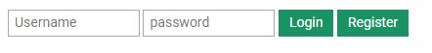
3. Select the button “Register as Franchise/Sustowns e-Kendra”
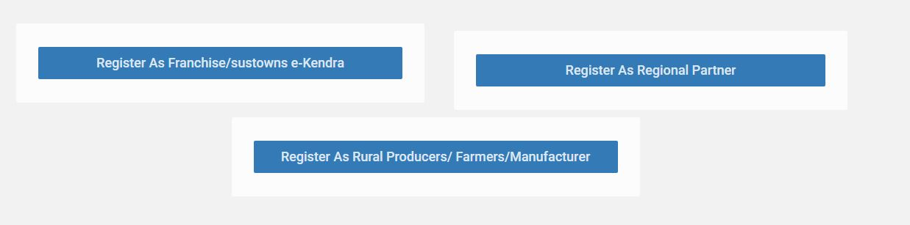
4. You will get Franchise Registration form
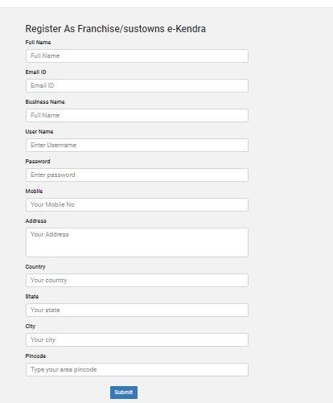
*Fill up all the fields in the form and remember your user ID and Password
5. Login by entering your username and password
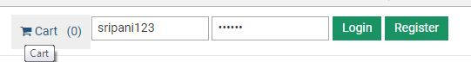
6. Once logged in you will be able to see the below mentioned dashboard
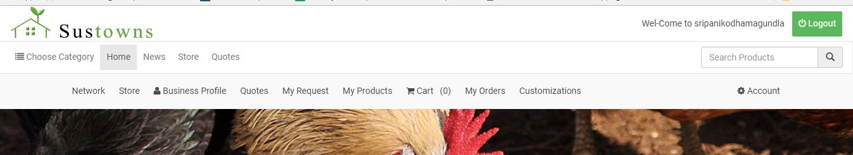
7. Click Accounts Tab and click on Vendor Management
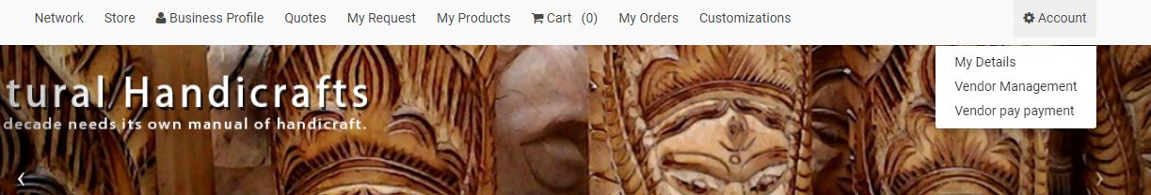
8. Now add your farmer and rural Producer details
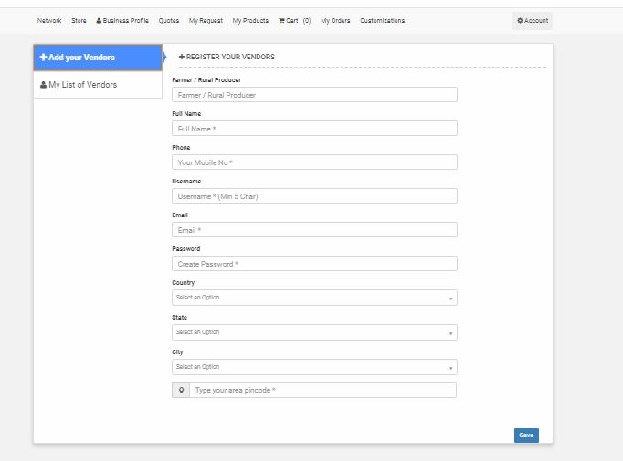
9. Once you complete the above you can go to my Products and enter all the product details of your vendors
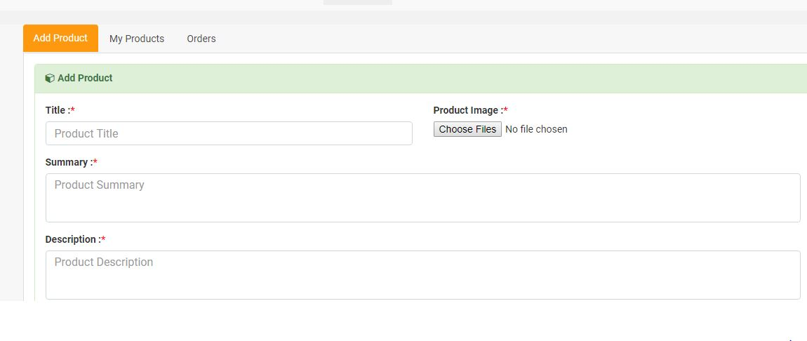
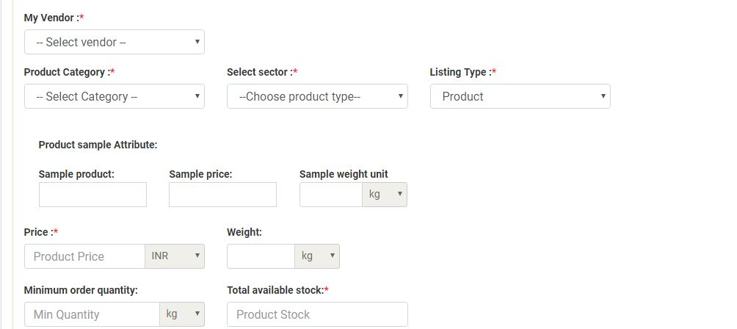
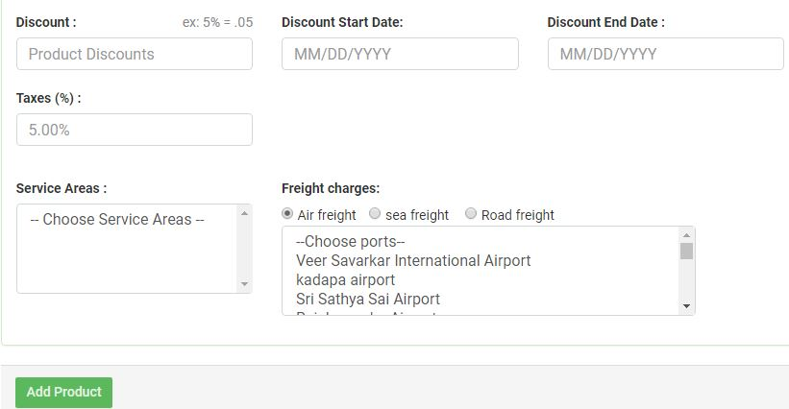
No need to fill up the service areas details and you can leave them empty

Now that you have registered yourself as franchise and added all your vendors and their product details
Thank you

